Day 1 Assignment:
2) Write a blog on Difference between HTTP1.1 vs HTTP2 ?
If we’re going to talk about the transition from HTTP/1.1 to HTTP/2, it’s worth taking a quick trip back to the flannel-soaked 1990s. Back then, HTTP was a simple protocol for a simple job – transporting documents from a web server to your computer as efficiently as possible. This is because the web was simple, made up of documents and a spattering of images that were no sweat for the hardware of the time to sling around.
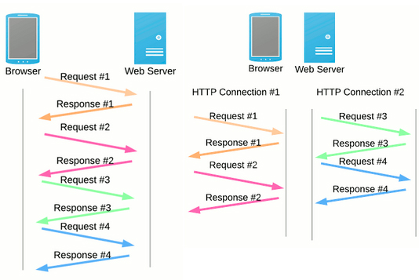
HTTP, which stands for Hypertext Transfer Protocol, saw wide adoption in the early 1990s to facilitate this, transferring “hypertext” documents. These were simple documents comprising mostly text and a few images, marked up with HTML to add formatting and links to other hypertext documents. By 1996, the 1.0 specification was adopted. This version was elegant and simple for the needs of the mid-90s web – make a connection, download a file, close the connection, and repeat for each file needed to display a web page.
By the tail end of the 90s, however, things began to change. The web was rapidly evolving beyond a glorified world-wide Choose Your Own Adventure full of linked documents to click through. People began buying and selling things, necessitating security. In addition to images, people wanted to watch videos and edit documents and send goofy animated greeting cards from their browsers. The strategy of one connection, one file was quite slow for these new use-cases.
So, in 1999, the w3 overseeing body updated the HTTP spec to version 1.1. This version was a bit of a stopgap, adding features to the 1.0 specification meant to improve the speed and efficiency of web servers powering this new “hypermedia” version of the web.

The HTTP/1.1 To HTTP/2 Transition:
The breaking point in HTTP/1.1 was reached well before the 2015 introduction of HTTP/2. In fact, Google was working on it’s own replacement for HTTP/1.1 since the early 2010s, called SPDY (pronounced “speedy”). This protocol used the existing infrastructure built for HTTP/1.1, but modified how the requests worked over the infrastructure. SPDY used multiplexing to download multiple resources efficiently over a single connection, and could be “back-ported” to existing applications with a translation layer.
It makes sense that Google would take the lead on this, as they had been developing increasingly complex web-based applications that operated more like desktop applications than websites, like GMail and Google Apps. In fact, the SPDY protocol was so well-designed, w3 used it as the basis for HTTP/2.
So, in 2015, w3 officially adopted the HTTP/2 specification based on SPDY, and all major browsers began supporting the protocol.
Today, the concept of “webpages” is anachronistic, in much the same way as “videotaping” something with your smartphone. Modern websites function much more like applications, with a constant two-way stream of data being an essential part of their functionality.
These are the high-level differences between HTTP1 and HTTP2:
- HTTP2 is binary, instead of textual
- HTTP2 is fully multiplexed, instead of ordered and blocking
- HTTP2 can, therefore, use one connection for parallelism
- HTP2 uses header compression to reduce overhead
- HTTP2 allows servers to “push” responses proactively into client caches

Disadvantages of HTTP/1.1:

Previously, HTTP/1.1 was the major version of HTTP network protocol used by the World Wide Web, implemented across clients and servers.
That worked well for 15 years. But as modern day applications and websites evolved and the amount of data to be loaded on a single page increased, the shortcomings of HTTP/1.1 became more prominent.

One Open Request Per Connection
HTTP/1.1 practically allows only one outstanding request per TCP connection (though HTTP pipelining allows more than one outstanding request, it still doesn’t solve the problem completely).
The browsers, to circumvent this limit, implement multiple parallel TCP connections to every domain (the number of parallel connections varied per browser). But this head-of-line blocking nature of HTTP/1.1 is a major bottleneck for faster loading applications.

Duplication Of Data
The other problem with HTTP/1.1 is the duplication of data across requests (cookies and other headers). Too many requests means too much redundant data, which would impact performance.
This led to the development of techniques like image sprites (combining multiple image requests into a single one) and domain-sharding (splitting the requests for resources over multiple domains to increase the number of possible parallel TCP connections).

Advantages Of HTTP/2:

HTTP/2 was built over Google’s SPDY protocol with the above short comings of HTTP/1.1 kept in mind. The main advantages of HTTP/2 over HTTP/1.1 as pulled from their Github page are –

Multiplexed, instead of ordered
Allows using same TCP connection for multiple parallel requests

Header compression using HPACK
Compressed headers, reduced data redundancy

Server Push
Instead of waiting for the client to request for assets like JS and CSS, the server can “push” the resources it believes would be required by the client. Avoids the round trip.

HTTP/2 in Action
While the basic advantages are mentioned above, let’s get a real-world example of the difference between HTTP/1.1 and HTTP/2 performance.
The demo page as shown below consists of an image split up into 100 smaller images. The image is loaded over both HTTP/1.1 and HTTP/2 side-by-side to show the difference in the loading performance because of multiplexing and header compression of HTTP/2.
Here is the difference in loading assets over HTTP/1.1 vs HTTP/2:
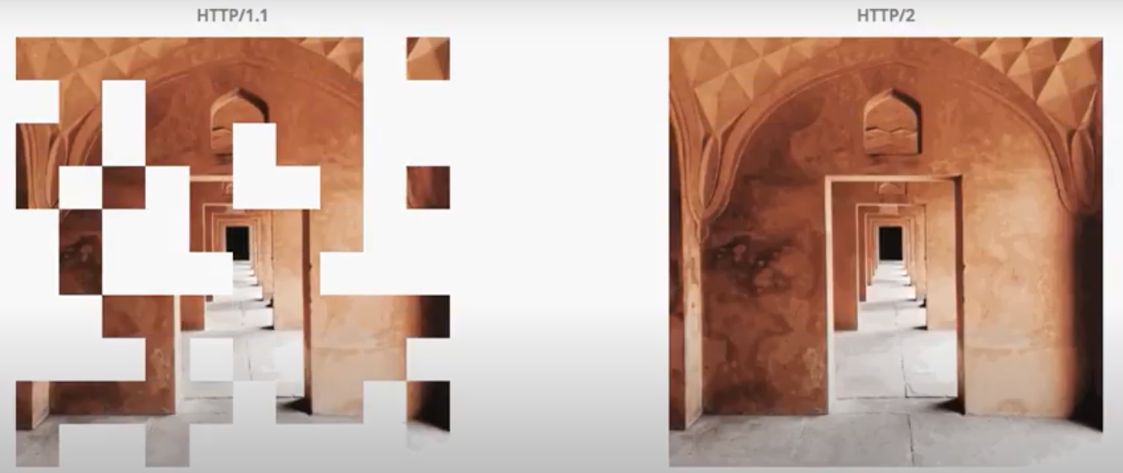
HTTP/2 is the clear winner. Once the first few assets start loading over HTTP/2, the following assets are loaded very quickly. This is not the case with HTTP/1.1, where the image assets keep loading for a longer time one after another (typical to pipelining in HTTP/1.1) to complete the full image.

